

The University of Azad Jammu and Kashmir, Muzaffarabad

Name Kamal Ali Akmal
Course Name | Software Designs and Architectures
Submitted to | Engr. Daniyal Nazir
Semester | 3rd
Session | 2024-2028
Roll No | 2024-SE-38
Lab No | 10
Submission date | 2 February 2026
Smart Home Automation System
Scenario Overview
A Smart Home Automation System controls devices such as Lights, Fans, and Air Conditioners.
The system must:
- Create different device objects dynamically
- Notify multiple users when a device’s status changes
- Provide a single, unified interface to control complex subsystems
To achieve this, suitable Design Patterns are identified and applied.

Task 1: Pattern Identification (Analysis)
1. Creational Design Pattern
Selected Pattern: Factory Method Pattern
Justification:
The Factory Method Pattern is used to create different smart device objects (Light, Fan, AC) dynamically without specifying their concrete classes. This improves flexibility and makes the system easy to extend when new devices are added.

2. Behavioral Design Pattern
Selected Pattern: Observer Pattern
Justification:
The Observer Pattern allows multiple users to observe smart devices and get notified automatically whenever a device’s status changes. This is ideal for real-time updates in a smart home system.
3. Structural Design Pattern
Selected Pattern: Facade Pattern
The Facade Pattern provides a single unified interface to control multiple smart devices. It hides the complexity of subsystems and allows users to control the smart home easily.
Task 2: UML Class Diagram (Design)
Selected Pattern for Diagram: Observer Pattern
Pattern Participants
- Subject: SmartDevice
- ConcreteSubject: Light / Fan / AirConditioner
- Observer: User
- ConcreteObserver: MobileUser / WebUser
Diagram Description (write this below diagram)
The UML class diagram represents the Observer Pattern used in the Smart Home Automation System. The SmartDevice acts as the Subject and maintains a list of observers. Users act as Observers and are notified whenever the device state changes. This ensures loose coupling between devices and users.
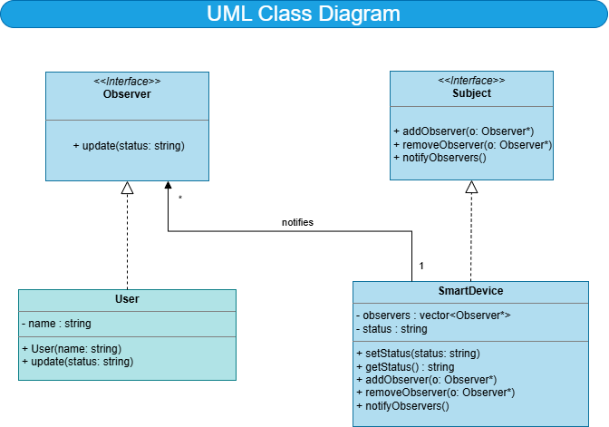
Task 3: Pattern Implementation (Coding)
Observer Design Pattern – Smart Home Automation System
Observer Interface
#include <iostream>
#include <vector>
#include <string>
using namespace std;

class Observer {
public:
virtual void update(string status) = 0;
virtual ~Observer() {}
};
Subject Interface
class Subject {
public:
virtual void addObserver(Observer* o) = 0;
virtual void removeObserver(Observer* o) = 0;
virtual void notifyObservers() = 0;
virtual ~Subject() {}
};

Concrete Subject (Smart Device)
class SmartDevice : public Subject {
private:
vector<Observer*> observers;
string status;

public:
void setStatus(string newStatus) {
status = newStatus;
notifyObservers();
}

string getStatus() {
return status;
}

void addObserver(Observer* o) override {
observers.push_back(o);
}

void removeObserver(Observer* o) override {
for (auto it = observers.begin(); it != observers.end(); ++it) {
if (*it == o) {
observers.erase(it);
break;
}
}
}

void notifyObservers() override {
for (Observer* o : observers) {
o->update(status);
}
}
};

Concrete Observer (User)
class User : public Observer {
private:
string name;

public:
User(string userName) {
name = userName;
}

void update(string status) override {
cout << "User " << name
<< " notified: Device status changed to -> "
<< status << endl;
}
};

Main Function (Testing the Pattern)
int main() {

SmartDevice light;

User user1("Ali");
User user2("Sara");
light.addObserver(&user1);
light.addObserver(&user2);

light.setStatus("Light is ON");
light.setStatus("Light is OFF");

return 0;
}

Explanation of Code
- Observer interface defines the update() method.
- Subject interface manages observers.
- SmartDevice acts as the Concrete Subject.
- User acts as the Concrete Observer.
- When the device status changes, all users are notified automatically.

Sample Output
User Ali notified: Device status changed to -> Light is ON
User Sara notified: Device status changed to -> Light is ON
User Ali notified: Device status changed to -> Light is OFF
User Sara notified: Device status changed to -> Light is OFF

Output Explanation (Write This)
When the device status changes, all registered users are automatically notified. This demonstrates the Observer Pattern by maintaining loose coupling between smart devices and users.

Conclusion
In this lab task, suitable design patterns were identified and applied to a Smart Home Automation System. The Factory Method Pattern enables dynamic device creation, the Observer Pattern ensures real-time user notifications, and the Facade Pattern simplifies system interaction. These patterns improve flexibility, reusability, and maintainability of the system.

